**10. Atmospheric scattering**

Extinction = absorption + scattering



single scattering albedo (SSA).



As before, except for polarization (which is quite important, although we largely neglect it), extinction, SSA, and the scattering phase function Φ completely describe a scattering event. For *single scattering* problems it is all that is needed.

**10.1 Scattering regime**

For scattering in general, there is an electric interaction (complex, with the dielectric and optical properties of the scatterer) involving electromagnetic induction and re-radiation.

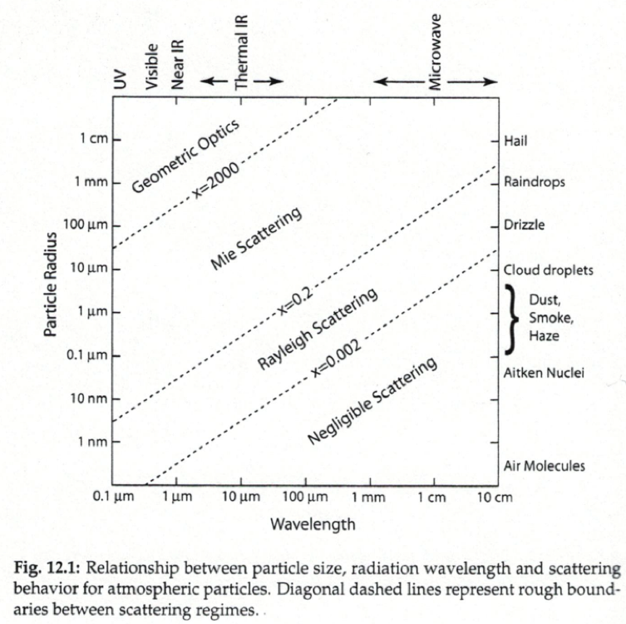

Figure 10.1 From Grant W. Petty, A First Course in Atmospheric Radiation, 2nd edition, Sundog Publishing, Madison, WI, 2006. Permission being sought.

**10.2 Polarization in scattering**

**Stokes vector, polarization ellipse**

Consider a monochromatic, coherent light wave with direction of propagation **z**, angular frequency *ω*, and propagation constant *k* (assuming an isotropic medium) described by

where The intensity and polarization state of this wave can be described by the 4-element Stokes vector, where



This general case of a coherent plane wave has elliptical polarization with a polarization ellipse (the ellipse swept out by the electric field vector onto a plane perpendicular to the direction of propagation) determined by the relative amplitudes *ax* and *ay* and phases *εx* and *εy*. Linear and circular polarizations are simply special cases of the ellipse.

Note that this is not a unique description of the polarization state, although it is the most common one, and also that there is an equivalent geometric version of this description in terms of the polarization ellipse, described by van de Hulst and by Goody and Yung (and others). Also, note that this actually over-determines the polarization state for coherent, elliptically-polarized, light where



In general, light beams are not coherent, as they are the superposition of many individual waves. If we look at time averages (denoted by ) over the duration of a scattering event, then



In this more general case, all four parameters (or their equivalent) are required, and it can be shown that The degree of polarization *P* is given by



If the light is completely unpolarized, and incoherent over this period (*e.g*., sunlight), then and



**Mueller matrix**

Any interaction, such as a scattering event, transmission, or reflection can be described by a 4 × 4 *Mueller* (or transformation, or scattering) matrix. Google Mueller matrix to see a nice assortment of examples for various optical interactions. Rayleigh scattering is described by the Mueller matrix

where *QR* is the scattering cross section.



**10.3 Rayleigh scattering**

Rayleigh scattering for a spherical molecule (*i.e*., an atom)

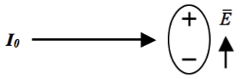

Figure 10.2 Scattering induced by an induced dipole moment (Rayleigh scattering). The phase function



The induced dipole moment re-radiates. Consider the polarization of the input and scattered light (*N.B*., solar radiation is unpolarized to a very high degree of accuracy):

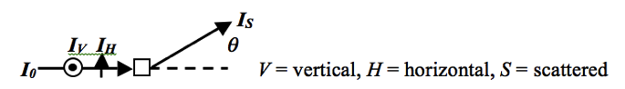

Figure 10.2 xxxx

For *IV*, Φ = constant (isotropic in the plane), vertically polarized

For *IH*, null at π/2, horizontally polarized, or:

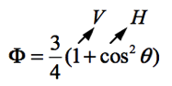

Figure 10.3 xxxx

Perpendicular to the plane of the paper, the opposite holds.

In general, the output intensities for scattering in the plane are proportional to:

|  |  |  |  |
| --- | --- | --- | --- |
|  | *V* in | *H* in | Unpolarized in |
| *V* out | 1 | 0 | 1 |
| *H* out | 0 | cos2θ | cos2θ |
| Total out | 1 | cos2θ | 1 + cos2θ |

The Rayleigh scattering cross section has been parameterized to, where *λ* is the wavelength in μm, and *Q* is in cm2.



The analytic form is where the polarizability *α* is (usually) quite weakly dependent on wavelength, except at wavelengths where electronic states of the atom or molecule are being excited (*e.g*., below 242 nm for O2).



In cgs units, the *permittivity of vacuum* The cross section above is thus the same as **Bernath**, eq. 8.70: The permittivity of vacuum (AKA permittivity of free space) from *Wikipedia* is a [physical quantity](http://en.wikipedia.org/wiki/Physical_quantity) that describes how an [electric field](http://en.wikipedia.org/wiki/Electric_field) affects and is affected by a [dielectric](http://en.wikipedia.org/wiki/Dielectric) medium, and is determined by the ability of a material to [polarize](http://en.wikipedia.org/wiki/Polarization_%28electrostatics%29) in response to the field, and thereby reduce the total electric field inside the material. Thus, permittivity relates to a material’s ability to transmit (or “permit”) an electric field. **Permittivity** is directly related to [electric susceptibility](http://en.wikipedia.org/wiki/Electric_susceptibility). For example, in a [capacitor](http://en.wikipedia.org/wiki/Capacitor), an increased permittivity allows the same [charge](http://en.wikipedia.org/wiki/Electric_charge) to be stored with a smaller electric field (and thus a smaller [voltage](http://en.wikipedia.org/wiki/Voltage)), leading to an increased [capacitance](http://en.wikipedia.org/wiki/Capacitance).



**Bernath** derives the Rayleigh cross section in eqs. 8.65-8.69 by taking the power emitted by a classical oscillating dipole moment and dividing by the power driving it:

The power emitted is The incident intensity is



and thus as given. Bernath notes that the equation for radiated power was discussed in his Chapter 1, but you won’t actually find it there specifically. However, it agrees, by implication, with the derivation in **Goody & Yung**:



**Goody & Yung** (Sections 7.1 through 7.3) actually does a complete derivation *except* that the most critical part is presented rather than developed. This is that for scattering by small particlesfor propagation to “longer” distances the electric field components are given bywhereand is the angle between *μ* and the direction of observation (see **Figure 7.2**).



Then, employ the *Poynting vector*, which measures the energy flux carried by an electromagnetic wave (in cgs units, (erg s-1 cm-2)) to determine radiated power versus direction, integrate over a sphere, and get total power emitted, as above, and the cross section (eq. 7.30).



**Depolarization: The inelastic Raman scattering component**

In general, the polarizability is not isotropic. For diatomics such as N2 and O2 (*i.e*., “air”)

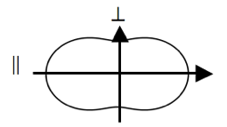

Figure 10.4 xxxx



*ε* (a measure of the effect of anisotropy on the spectrum) is defined as



The corresponding *depolarization factor* or *ratio*, defined as the ratio of the horizontally polarized component to the vertically polarized component of the scattered light for unpolarized input at 90o scattering angle in the horizontal plane, is given by



The induced dipole moment allows rotational *Raman* transitions – Raman scattering is simple the *inelastic* part of Rayleigh scattering.

The rotational Raman transitions usually have selection rules (as opposed to the usual for electric dipole transitions).



*Stokes* transitions; *I0* loses energy to molecule.



*anti-Stokes* transitions; *I0* gains energy from molecule.



(polyatomics are naturally more complicated)

Because molecules rotate before re-emitting, the scattered radiation is less polarized (but not completely unpolarized).

Complete intensities, (the last two pre-Bodhaine) and polarized scattering phase functions are described in *Chance and Spurr*, 1997



(<http://cfa-www.harvard.edu/atmosphere/>) and given in ringdata.txt. Also, see table, below.

Vibrational Raman scattering is in general much weaker and less important in atmospheric scattering, but it is not entirely absent. Here, the transitions are almost entirely Stokes. (*See why?*)

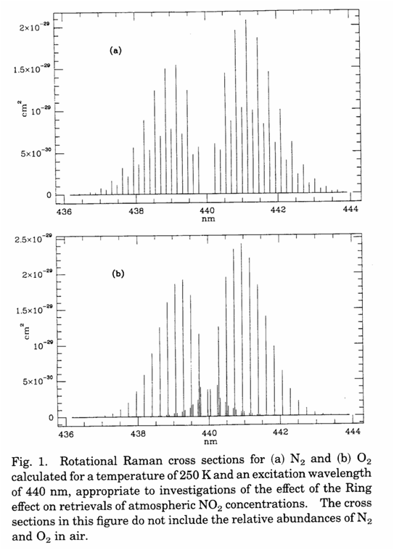

Figure 10.5 From Chance and Spurr, 1997.

Also, liquid water (*i.e*., in the oceans) can be important, for ocean color sensing. Here it is mostly due to *librational* Raman (intermolecular transitions). Raman scattering from sea ice may prove useful in the future.

For air, at wavelengths 300 nm ≤ λ ≤ 500 nm, 3.8% of Rayleigh scattering is inelastic (Raman) scattering. Since the Raman scattering is a component of Rayleigh scattering, it also has the λ-4 wavelength dependence.

The occurrence of Raman scattering in atmospheric spectra is called the *Ring Effect* (after Grainger and Ring, 1962), who noticed Fraunhofer lines shapes changing with air mass (becoming broader and less deep with increasing air mass) during zenith sky measurements at various solar zenith angles.

**Relative Rayleigh and Raman Scattering Intensities†**

|  |  |  |
| --- | --- | --- |
| *V* Polarization in | *H* Polarization in | Sum (Natural Light in) |
|  |  |  |
| Rayleigh-Brillouin |  |  |
| *VCV* = 180 + 4ε | *HCV* = 3ε | 0*CV* = 180 + 7ε |
| *VCH* = 3ε | *HCH* = 3ε + (180 + ε) cos2θ | 0*CH* = 6ε + (180 + ε) cos2θ |
| *VC*0 = 180 + 7ε | *HC*0 = 6ε + (180 + ε) cos2θ | 0*C*0 = (180 + 13ε) + (180 + ε) cos2θ |
|  |  | ρ0*C* = 6ε / (180 + 7ε) |
| Raman |  |  |
| *VWV* = 12ε | *HWV* = 9ε | 0*WV* = 21ε |
| *VWH* = 9ε | *HWH* = 9ε + 3ε cos2θ | 0*WH* = 18ε + 3ε cos2θ |
| *VW*0 = 21ε | *HW*0 = 18ε + 3ε cos2θ | 0*W*0 = 39ε + 3ε cos2θ |
|  |  | ρ0*W* = 6 / 7 |
| Sum |  |  |
| *VTV* = 180 + 16ε | *HTV* = 12ε | 0*TV* = 180 + 28ε |
| *VTH* = 12ε | *HTH* = 12ε + (180 + 4ε) cos2θ | 0*TH* = 24ε + (180 + 4ε) cos2θ |
| *VT*0 = 180 + 28ε | *HT*0 = 24ε + (180 + 4ε) cos2θ | 0*T*0 = (180 + 52ε) + (180 + 4ε) cos2θ |
|  |  | ρ0*T* = 6ε / (45 + 7ε) |

**†**Mostly from Kattawar *et al*., *Astrophys. J*. **243**, 1049-1057, 1981.

The complications to UV (especially) and visible atmospheric measurements are several:

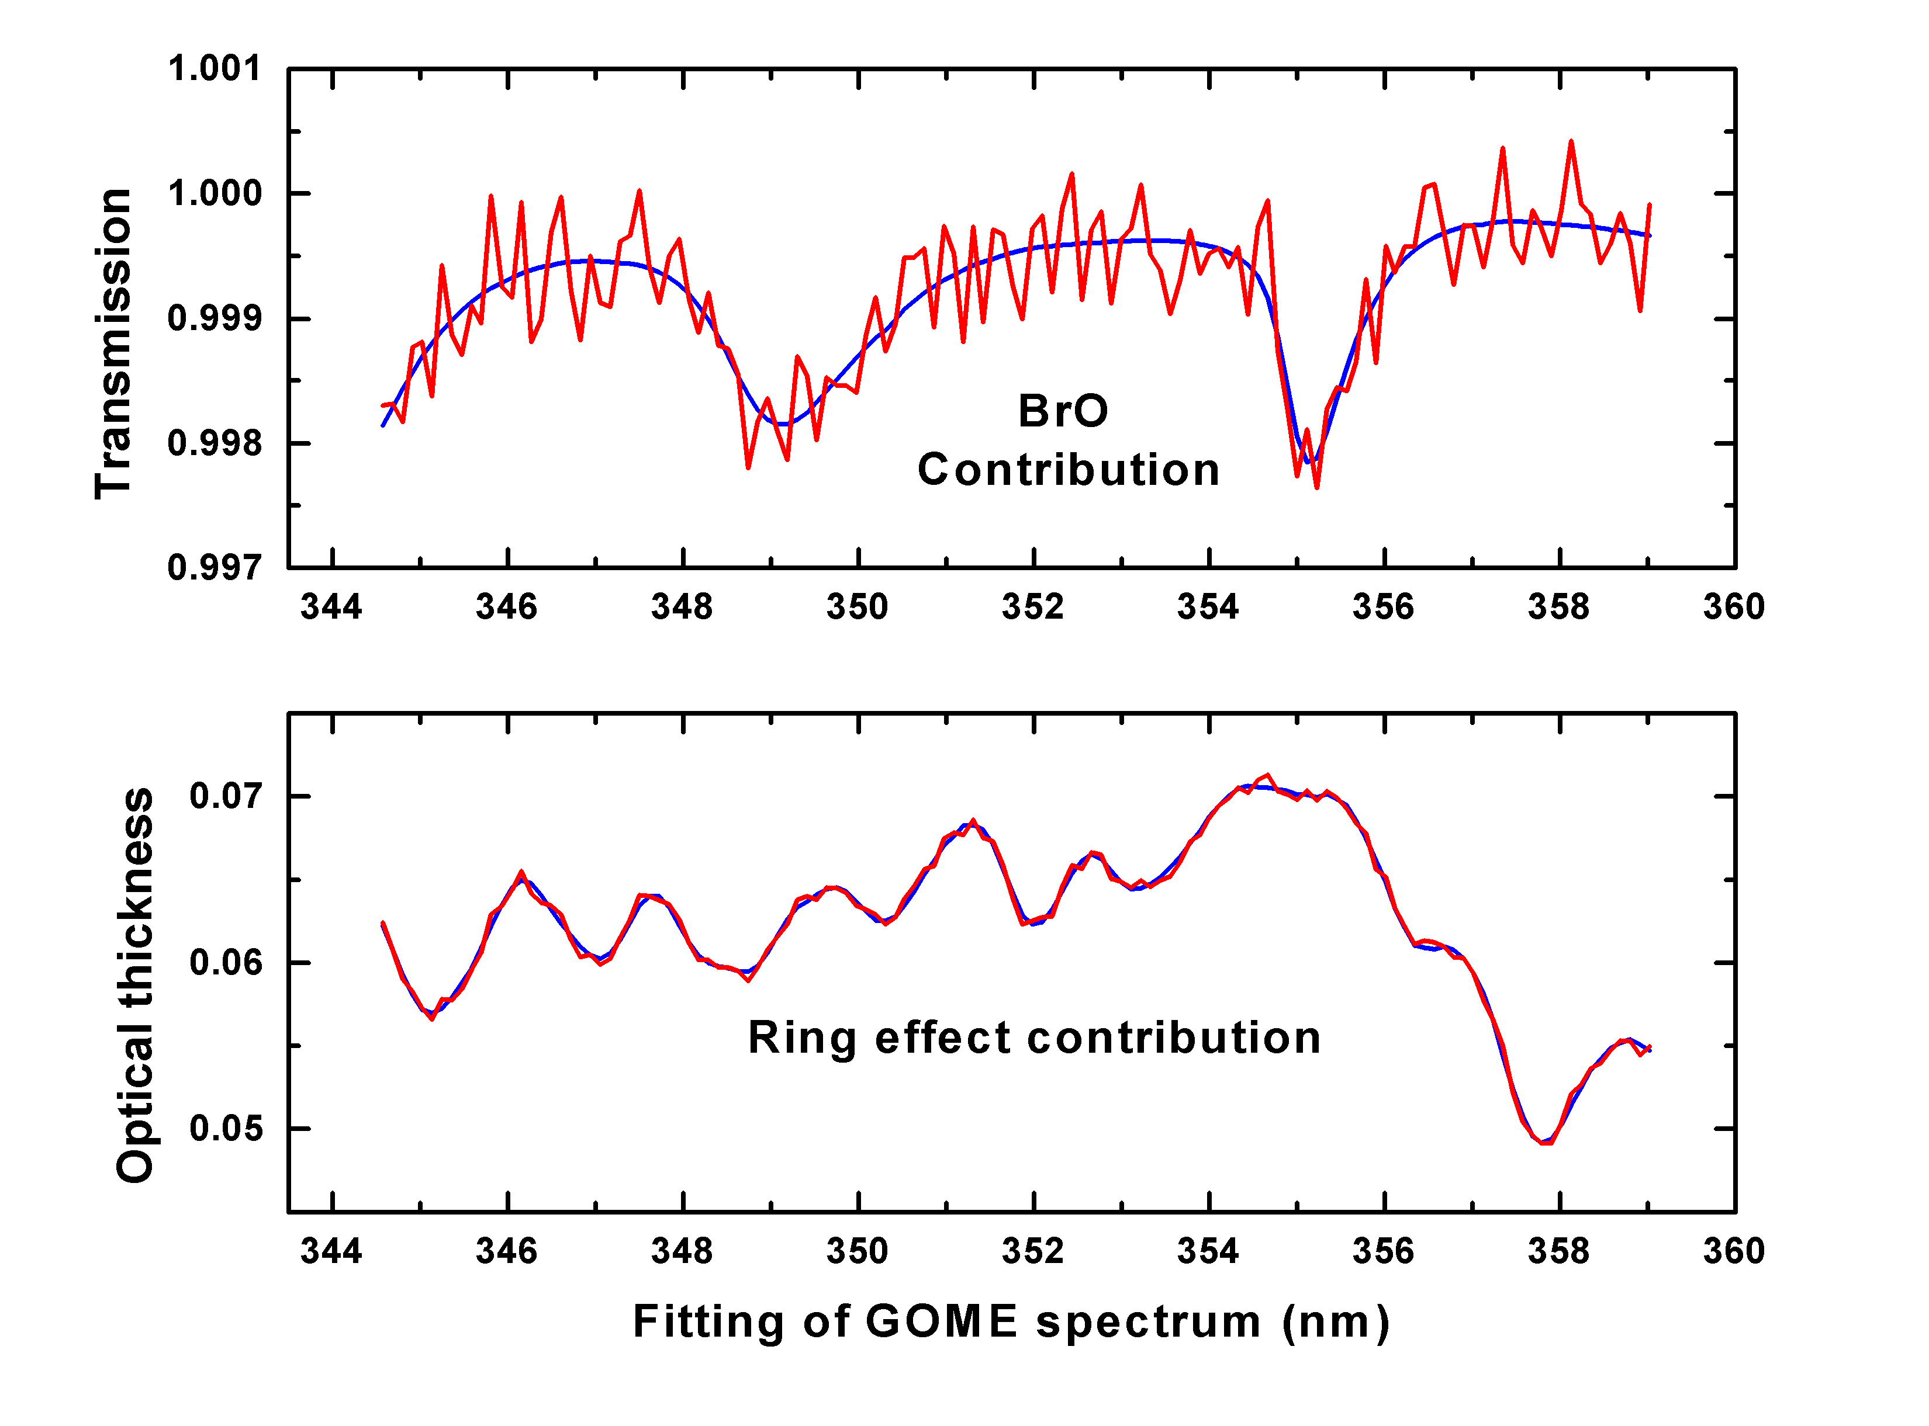**1.** *I* ÷ *I0* only to 96% (for the single-scattering Rayleigh part of the source), while we are generally trying to fit absorptions to much better than 1%. Accurate Ring effect corrections must be made. Here is an example of fitting for BrO in a GOME spectrum showing that we can fit very precisely for BrO (to better than 3×10-4 RMS in this case) even in the presence of Ring effect structure that is about 10 times as large as the BrO absorption.

**2.** The amount of Ring effect is proportional to the number of air molecules encountered: It can be used to help determine cloud amount (*cf*. J. Joiner and P. K. Bhartia, The determination of cloud pressures from rotational Raman scattering in satellite backscatter ultraviolet measurements, *J. Geophys. Res*. **100**, 23,019– 23,026, 1995).

The effect on Fraunhofer shapes is often referred to as *filling-in* since it makes the Fraunhofer lines broader and less deep. There are *filling-in factors* and *filling-in spectra*, as examples (often with varying definitions). Filling-in is an instrument-dependent quantity and a departure from the basic physics. I prefer not to use it unless more basic descriptions fail – which I have never seen happen.

The simplest way to take the Ring effect into account when fitting an atmospheric spectrum is to calculate a Ring single-scattering corrections as where is the Fraunhofer spectrum and the are the rotational Raman cross sections.



Higher-order corrections may be obtained to account for interference from strong atmospheric absorption (*e.g*., by O3 in the UV Huggins bands) as



and forming an orthogonal set of correction spectra using a *Gram-Schmidt* orthogonalization process.

For GOME, this technique has been tested against Ring corrections using radiative transfer modeling calculations; it consistently gives the best results. It is used operationally in GOME, SCIAMACHY, and for some gases in OMI.

For ground-based measurements, an experimental Ring correction spectrum may be derived by making measurements at two polarizations, measuring at two significantly different angles with respect to the Sun (usually, but not necessarily, perpendicular and parallel to the direction to the Sun [Solomon *et al*., 1987]) and using an algebra derived from Table 1 of *Chance and Spurr*, 1997 or Table I of Kattawar *et al*., 1981 (which supplied most of the *Chance and Spurr* table) to derive the Raman scattered component.

**10.4 Mie scattering**

**Mie scattering**

Aerosols and clouds, especially. Horribly complicated general solutions, lots of oscillations in phase functions, which average out over size distributions.

Details in *Goody and Yung*, Chapter 7, and in notes from J. Wang.

Note the distinction between absorbing and non-absorbing aerosols: Complex index of refraction, . *(NB black carbon vs. sulfates, clouds)*



Transmission Since leads to extinction.



A typical Mie setup for computation (W. Wiscombe in Disort test code) has 82 Legendre terms in a typical *haze* and 299 terms in *cloud*.

Mie scattering is strongly *forward-peaked* (tea kettle example), sometimes with a secondary backward, structured peak (a *glory*).

The Henyey-Greenstein phase function is a common practical Mie phase approximation with nice analytic properties:

where *g* is the *asymmetry parameter*. is typical for atmospheric aerosol. This Henyey-Greenstein phase function misses the back scattering peak. This can be treated using the double Henyey-Greenstein phase function:



where



*Goody and Yung* give a typical atmospheric example (maritime haze @ 0.7 μm):



For Φ*HG*, *m*0 = 1, *m­l* =



For the double *HG*,



Finally, note the weak wavelength-dependence of Mie scattering compared to Rayleigh scattering; it is sometimes *(Or some other low power)*



For Mie scattering by clouds and aerosols, the most common distribution of sizes is *log-normal*: where *σ* is the *shape parameter*, the ln of the standard distribution in width.



*Shettle and Fenn* (see references) is a standard source for aerosol information. They describe atmospheric aerosol distributions as either one or the sum of two log-normal distributions.

**Expansion in Legendre polynomials**

Legendre polynomials are often convenient in scattering problems to expand the phase function Φ. The preferred (my preferred) definition for Legendre polynomials is:



First several:



They form an *orthonormal* basis set. In order to generate them:



Phase function expansion is given in general as:



Expansion of the phase function is important in radiative transfer modeling. The required number of expansion terms is limited by the number of terms in the radiative transfer expansion itself (about which more later). For Rayleigh scattering,

*m*0 = 1

*m*1 = 0

*m*2 = 1/10

*m*>2 = 0



A Rayleigh Φ with *depolarization* (because of the *Raman* component, as before) is:

where *δ* is the *depolarization factor* (= 0.0295 for air at 400 nm wavelength). for unpolarized input (check that for pure Rayleigh scattering!) for this phase function,



*m*0 = 1

*m*1 = 0



*m*>2 = 0

**10.5 Aerosol types and optical properties**

- Atmospheric loading and size distributions

- The Ångstrom exponent

- Modeling approaches for non-spherical particles

**10.6 Cloud properties**

**10.7 Single and multiple scattering**

**References**

10.1

10.2

See **van de Hulst**, Chapter 5, **Chandrasekhar** Chapter 15, and **Goody and Yung** 2.1.3 and following, and my favorite, **Liou**, Chapters 5 and 6.

10.3

10.4

10.4 See *Chandrasekhar* for copious details and also *Goody & Yung* Chapters 7 (Mie scattering) and 8.

10.5

10.6

10.7

**Problems**

10.1 Show that  (*Try it!*)

10.2 What is the Mueller matrix for Lambertian reflection?